Applicant’s Name: _______________________________________________________________________________
LAST FIRST MIDDLE INITIAL
Social Security Number: XXX-XX-_________ Application Date: _____________________
Complete this form when official secondary documentation is unavailable after reasonable attempts have been made. Check all applicable statements, fill in requested details, and complete the sign-off sections that apply to your current situation.
☐High School Graduate/GED: I received my high school diploma/equivalent on ___________________ from
__________________________________ in _______________________________.
☐Not Attending / High School Dropout: I am not currently enrolled in school. I withdrew on ________________
from ____________________________________. Highest grade completed: ____________________.
☐ Currently Attending School: Enrolled at _________________________. Enrollment Date: ________________.
(Note: Adult Education and non-credit courses are excluded).
☐Currently Employed: Employer: _____________________________ Hourly Wage: $___ Avg. Hours/Week:_____
☐Unemployed: Weeks unemployed: _____ Last Job Title: ___________________________
Last Employer: ___________________________ Separation Date: ________
Reason Job Ended: ☐Layoff / Reduction in Force ☐Terminated ☐Quit ☐Other: ____________

☐ Never Worked: I have no prior formal work experience.
☐ I received a notice of termination, mass layoff, or WARN Act notice.
☐ I am receiving or have exhausted Unemployment Insurance (UI) benefits.
☐ I was self-employed and am now unemployed due to general economic conditions or natural disaster.
☐ In the past 6 months, I or a member of my household received SNAP (Food Stamps), TFA, SSI, SAGA, or RCA.
☐ I self-identify as an individual with a physical, mental, or learning disability.
☐ I lack a fixed, regular, and adequate nighttime residence, or I am living in a shelter/temporary housing.
☐ I have been subject to any stage of the criminal justice system (arrest, conviction, probation, or court supervision).
☐ I am pregnant or a custodial/non-custodial parent.
☐ English is not my native primary language. Native language: ________________
☐ I am currently in foster care or have aged out of the foster care system.

I HEREBY CERTIFY UNDER PENALTY OF PERJURY THAT THE INFORMATION PROVIDED ABOVE IS TRUE, COMPLETE, AND ACCURATE TO THE BEST OF MY KNOWLEDGE.
I understand that the information stated on this form is subject to official state and federal verification. I further understand that misrepresentation, fraudulent statements, or intentional omission of information may result in immediate termination of WIOA-funded programs/services and/or legal penalties as specified by law.
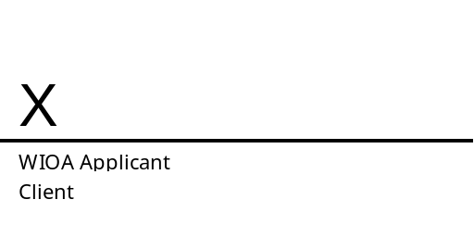
STAFF USE ONLY (VERIFICATION & REVIEW) Staff must complete this section upon reviewing the self-attestation details with the applicant.


